**Crown Preparatory Academy**

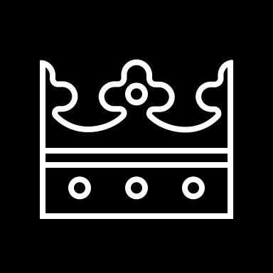

**AUTHORIZATION FOR RELEASE OF SCHOOL STUDENT RECORDS**

I, _**____**____________________________________________________, __ Parent __Legal Guardian, authorize____________________________________________________________________.

PREVIOUS DISTRICT & SCHOOL NAME AND ADDRESS

to release records checked below, regarding ______________________________________________

STUDENT

____/____/____, to: _______**CROWN PREPARATORY ACADEMY**_____ _ _ (_614 ) -_636 -_3775__

BIRTHDATE. SCHOOL NAME PHONE

___ **2300 N CASSADY AVE, COLUMBUS, OH 43219**____________ ________

SCHOOL STREET ADDRESS, CITY, STATE, ZIP CODE

for the purpose of__ **school enrollment**_____________.

|  |
| --- |
| **RECORDS TO BE RELEASED**  The records released shall cover the dates of ___/___/___ to ___/___/___. (Optional)  PERMANENT RECORDS   * Student’s Name, Address, DOB, Birthplace, Gender, Birth Certificate * Attendance Records * Academic Transcript * Honors/Awards received * Parent’s Name(s), Address(es) * Participation in Extracurricular Activities * Disciplinary Information * Special Education Records * Test Scores: intelligence, aptitude, achievement levels * IEP * Psychological Evaluations * Educational Evaluation &Reports * Speech, Physical, or Occupational Therapy Evaluations/Reports * Medical/Nursing Records * Other * All of the above |

I understand that I have the right to inspect, copy, and challenge the content of the school student records for which I am authorizing release. I also have the right to designate the school student records to be release or to identify specific portions of a school record to be released by this consent. Any such limitations have been above noted.

**________________________________________________________________ ________________________________**

AUTHORIZED SIGNATUREDATE